**Key takeaways**

1. **List comprehension** allows you to create new lists from existing ones in a concise and elegant way. The syntax of a list comprehension looks as follows:

[expression for element in list if conditional]

which is actually an equivalent of the following code:

for element in list:

if conditional:

expression

Here's an example of a list comprehension ‒ the code creates a five-element list filled with the first five natural numbers raised to the power of 3:

cubed = [num ** 3 for num in range(5)]

print(cubed) # outputs: [0, 1, 8, 27, 64]

2. You can use **nested lists** in Python to create **matrices** (i.e., two-dimensional lists). For example:

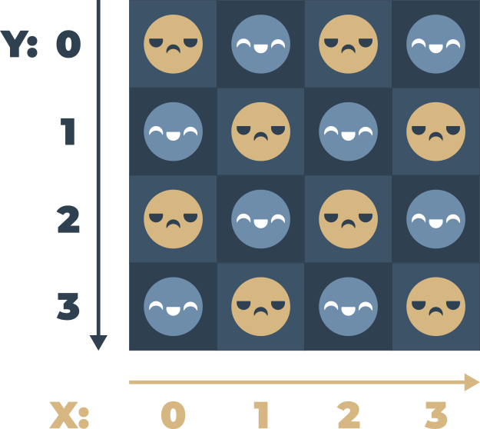

# A four-column/four-row table ‒ a two dimensional array (4x4)

table = [[":(", ":)", ":(", ":)"],

[":)", ":(", ":)", ":)"],

[":(", ":)", ":)", ":("],

[":)", ":)", ":)", ":("]]

print(table)

print(table[0][0]) # outputs: ':('

print(table[0][3]) # outputs: ':)'

3. You can nest as many lists in lists as you want, thereby creating n-dimensional lists, e.g., three-, four- or even sixty-four-dimensional arrays. For example:

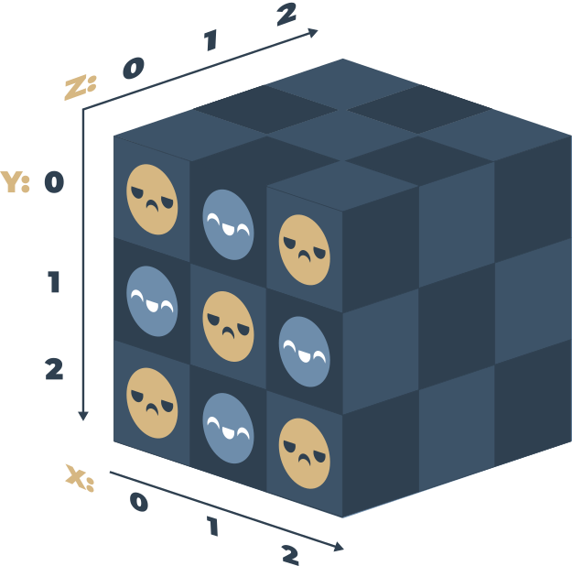

# Cube - a three-dimensional array (3x3x3)

cube = [[[':(', 'x', 'x'],

[':)', 'x', 'x'],

[':(', 'x', 'x']],

[[':)', 'x', 'x'],

[':(', 'x', 'x'],

[':)', 'x', 'x']],

[[':(', 'x', 'x'],

[':)', 'x', 'x'],

[':)', 'x', 'x']]]

print(cube)

print(cube[0][0][0]) # outputs: ':('

print(cube[2][2][0]) # outputs: ':)'